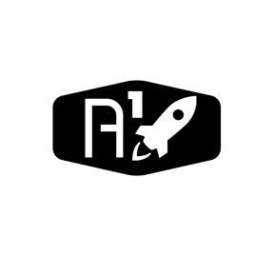

DESIGN DOCUMENT

Area : Converse Engine

Category: Feed (Piping)

TEAM: Propulsion

Nyameaama Gambrah

Tap-Off Description

Electrical



Tap-off propellant line

Initial Propellant Line

valve

valve

2-way pipe